Society of Petroleum Engineers
Distinguished Lecturer 2015-2016 Lecture Season

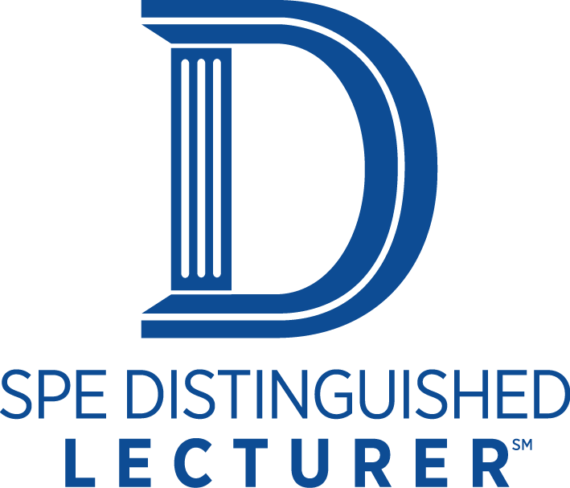

Optimism in Reservoir Production Forecasting – Impact of Geology, Heterogeneity, Geostatistics, Reservoir Modeling, and Uncertainty

William (Scott) Meddaugh

Midwestern State University

Abstract:

The oil and gas industry uses static and dynamic reservoir models to assess volumetrics and to help evaluate development options via production forecasts. The models are routinely generated using sophisticated software. Elegant geological models are generated without a full understanding the limitations imposed by the data or the underlying stochastic algorithms. Key issues facing reservoir modelers that have been evaluated include use of reasonable semivariogram model parameters (a measure of heterogeneity), model grid size, and model complexity. However, reservoir forecasts tend to be optimistic – a statement not provable with data in the public domain. Yet, conversations at technical meetings, the lack of industry publications highlighting actual forecast accuracy, the development of more detailed reservoir models (presumably to yield better forecasts), all suggest that the industry could improve its reservoir performance forecast accuracy. For example, dynamic models that use larger grid cells yield optimistic forecasts for some recovery processes as compared to forecasts obtained from models built with smaller grid sizes. Also, the use of stochastic earth models and well placement optimization workflows will likely yield optimistic forecasts. Overall, the impact of cell size, model parameters, inadequate use of analog data, and poorly constrained well location optimization may increase forecast optimism by 5-10 recovery factor units or more. Knowing what workflow aspects may contribute to forecast optimism should enable the industry to generate more reliable forecasts and make better use of capital.

Biography:

Dr. Meddaugh joined the Midwestern State University in 2013 as the RL Bolin Distinguished Professor of Petroleum Geology. He has 32 years of experience with Chevron including technical project management experience on projects in the United States, Canada, Venezuela, Middle East, West Africa, and Australia. He is a member of the SPE, AAPG, and EAGE and is an Associate Editor for the SPE Reservoir Evaluation and Evaluation Journal. He received a PhD in geology from Harvard in 1983. He has authored or co-authored over 30 peer reviewed and SPE technical papers on forecast optimism, reservoir characterization, and modeling.=

